Client Intake Form Today’s date _______
Personal Information
Name_________________________ Phone________________ Email__________________
Address________________________________
City______________________________ State_____________ Zip________________
DOB_____________________ Occupation_____________ Employer____________________
Emergency Contact__________________Relationship___________ Phone_________________
Are you a minor under the age of 18?________
The following information will be used to plan safely for effective massage and skin care sessions.
Have you ever had a professional massage/skincare session before? Yes / No
If yes, how often?
What are your goals for your massage and or skin care?
Do you have any difficulty lying on your front, back, or side?
Do you have sensitive skin?
What type of pressure do you prefer? Light / Medium / Deep
Are you clostrophobic?
Do you have any sensitivities or allergies to oils, lotions, ointments, citrus, fruits or nuts? _____
If yes, please explain:
Are you wearing contact lenses, hearing aids or dentures? __________
Are there any areas (ie: face, abdomen, feet) you do not want touched or massaged? ________
Do you sit for long hours at a work station, computer or driving? Yes/ No
Are there any areas of the body you are experiencing tension, stiffness, pain or other discomfort? Yes/ No
If yes, please describe:
Client information and consent for waxing clients only.
Do you use any Retin-A/ Vit. A derivatives/ Acutane?
Are you going sun tanning in the next 24 hours?
(Female clients) When is your next menstrual cycle due to begin?______ (Always allow five days for menstrual cycle. Because the skin will be more sensitive, water retention and for your own personal comfort, you should avoid hair removal two- three days before your cycle is due and two days after it is completed.) Please note that waxing does have certain side effects such as skin removal, redness, swelling, tenderness, etc.
Medical Information
Are you currently under medical supervision? Yes / No
If yes, please explain:
Are you taking any medications/ are you currently on any antibiotics? Yes/ No
If yes, please list name and use:
Do you see a chiropractor? Yes/ No If yes, how often?
Are you pregnant? Yes/ No If yes, how far along/ Any risk factors?
Do you suffer from chronic pain? Yes/ No If yes, please explain:
Have you had any orthopedic surgeries? Yes/ No If yes, please explain:

Please indicate any conditions you have had in the past or currently have.
Arthritis Easy Bruising
Atherosclerosis Fibromyalgia
Allergies/Sensitivity Kidney Dysfunction
Blood Clots / Deep Vein Thrombosis Numbness
Carpal Tunnel Syndrome Neuropathy
Cancer Open Wounds or Sores
Current Fever Circulatory Disorder
Contagious Skin Condition Decreased sensation
Headaches/ Migraines High/Low Blood Pressure
Heart Attack/ Heart Condition Joint Replacement
Recent accident or injury? Recent surgery?
Tennis elbow/Golfers Elbow Sprains or strains?
Swollen Glands TMJ
Joint Disorder/ Rheumatoid Arthritis/ Osteo Arthritis/ Osteoporosis/ Tendonitis
Please explain any of the conditions you have marked above:
Please circle any areas of discomfort:
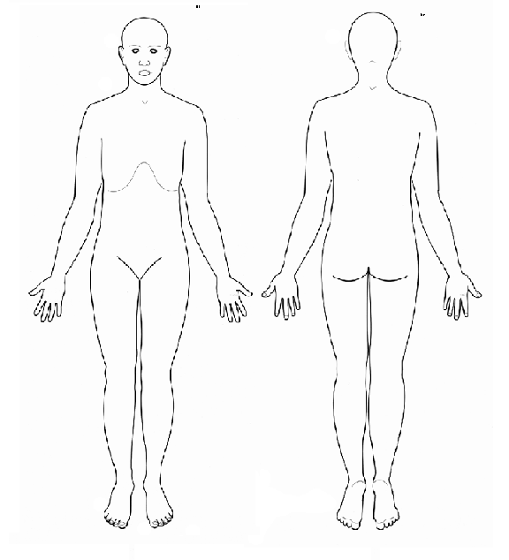
Is there anything else about your health history that you think would be useful for your massage/skincare practitioner to know in order to plan safe and effective sessions for you?

Draping will be used during the session. Only the area being worked on will be uncovered. Informed written consent must be provided by parent or legal guardian for any client under the age of 18. Fenton Healing Arts requires a 60% deposit. We require a credit card on file for all appointments to secure your allotted time with the service professional, which includes gift cards. All gift certificates and products are considered final sale and are non-refundable. Please be advised of our 24 hr cancellation policy, as cancellations will be accepted 24 hours prior to your appointment time. If you cancel within 24 hours of your scheduled service, you will be charged 100% of the scheduled treatment or treatments. No show appointments will be handled as late cancellation appointments and be charged 100% of the service(s). Exceptions such as inclement weather will be taken into consideration, however if you feel uncomfortable as inclement weather approaches, please give 24 hours notice to cancel your appointment.
I ______________________(print name) understand that the massage/ skincare I receive is provided for the basic purpose of relaxation and relief of muscular tension. If I experience any pain or discomfort during my session, I will immediately inform the therapist so that the pressure and/or strokes may be adjusted to my level of comfort. I further understand that massage/ skin care should not be construed as a substitute for medical examination, diagnosis or treatment that I am aware of. I understand that massage/skincare therapists are not qualified to perform spinal or skeletal adjustments, diagnose, prescribe or treat any physical or mental illness, and that nothing said in the course of the session given should be construed as such. Certain massages/skincare should not be performed under certain medical conditions, as so I affirm that I have stated all of my known medical conditions and answered all the questions honestly and to the best of my ability. I agree to keep the therapist updated as to any changes in my medical profile and understand there shall be no liability on the therapist if I fail to do so. I understand that any sexually suggestive remarks or advances made by me, will result in immediate termination of the session. I also understand that the licensed massage/skincare therapist reserves the right to refuse to perform massage/skincare on anyone whom he/she deems. Therefor, I assume all risk for my health and hold harmless Fenton Healing Arts, LLC and any associated business entities, practitioners, amenities or any persons involved in services performed. Please do not hesitate to contact us with any questions at 203-300-4486/ 203-751-0467.
Signature of Client ______________________________ Date ______________

